**Advance DevOps lab**

**Experiment 6**

**Name: BALOCH MUZAMMIL HAFEEZ ROLL NO: 612012**

**Semester: V**

**Branch: Information Technology**

1. **To create a Lambda function which will log “An Image has been added” once you add an object to a specific bucket in S3. Use AWS Lambda blueprint.**

Step 1: Management Console Dashboard.

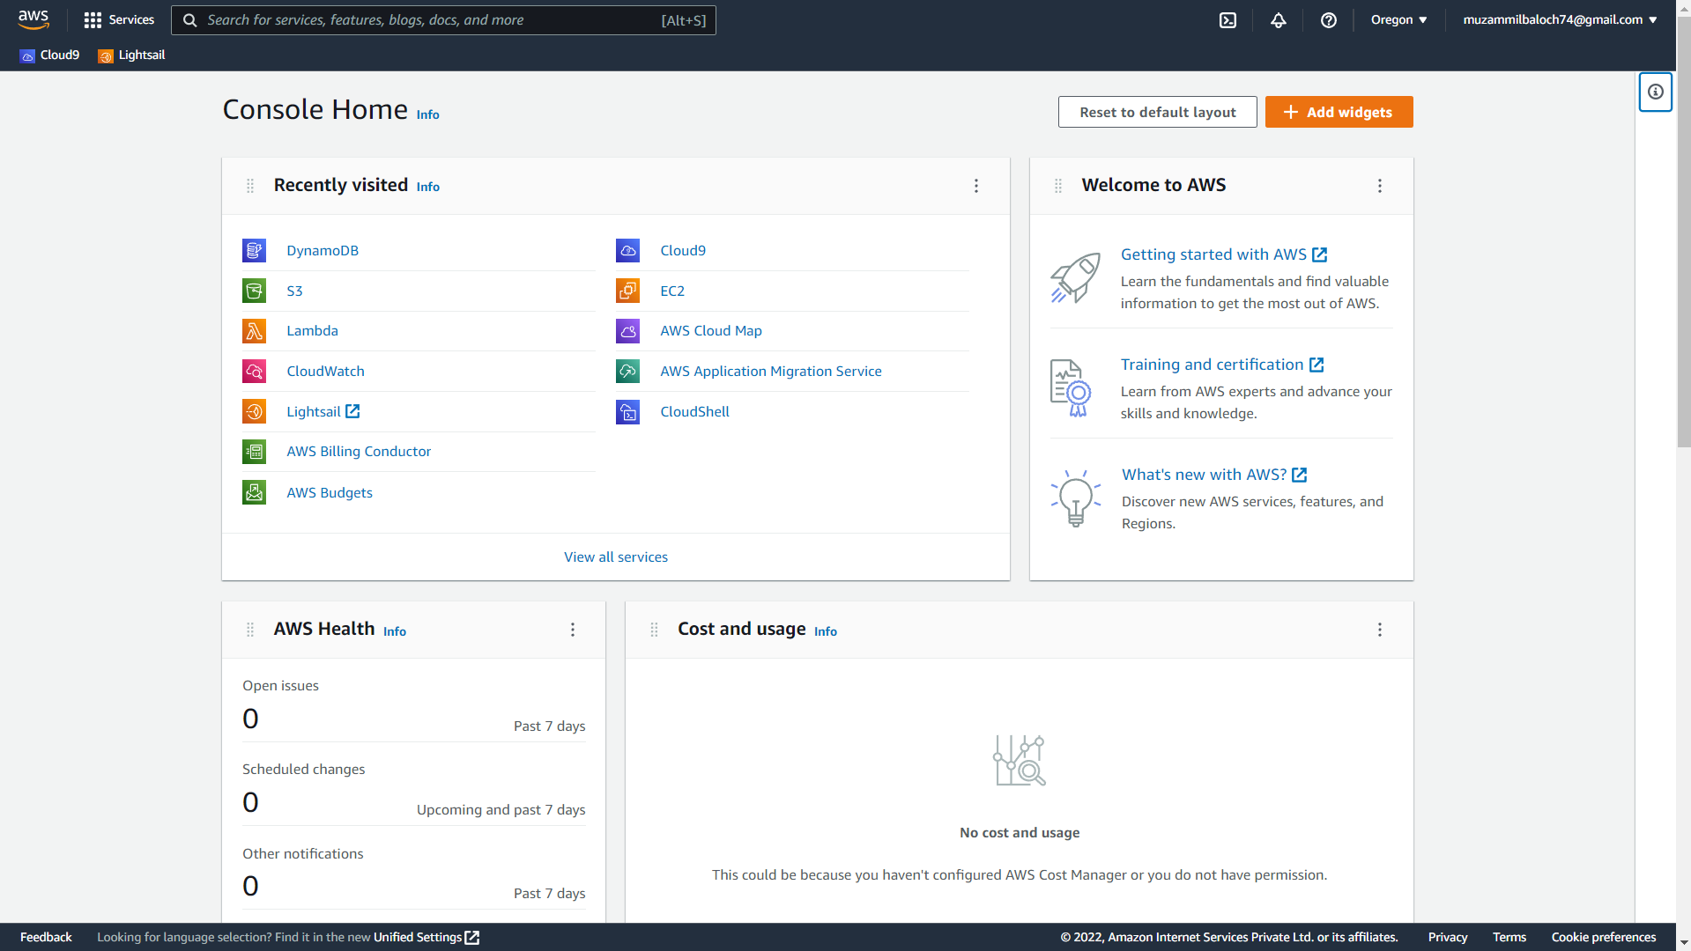

Step 2: Click on services and then click on S3.

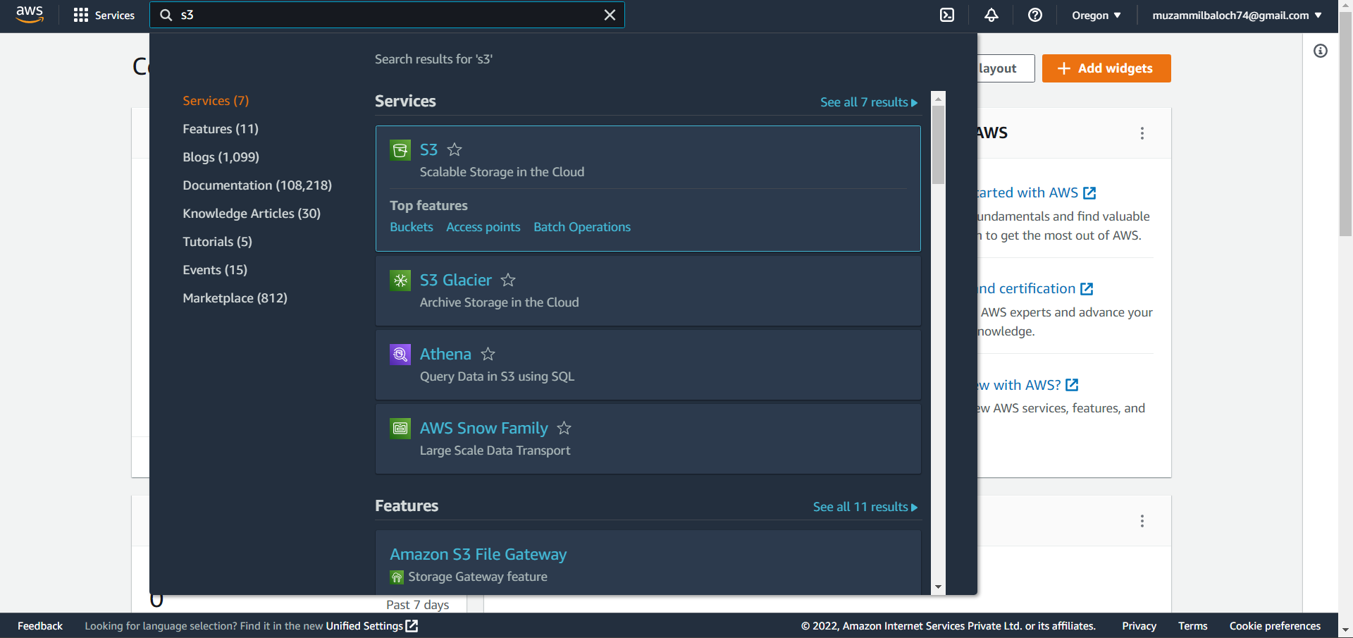

Step 3: Create a bucket.

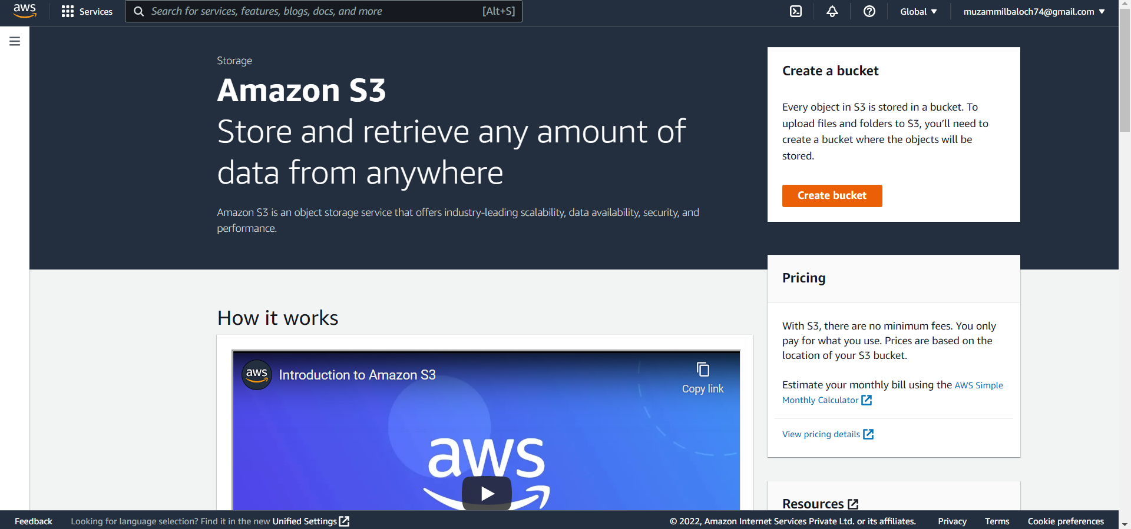

Step 4: Name the bucket.

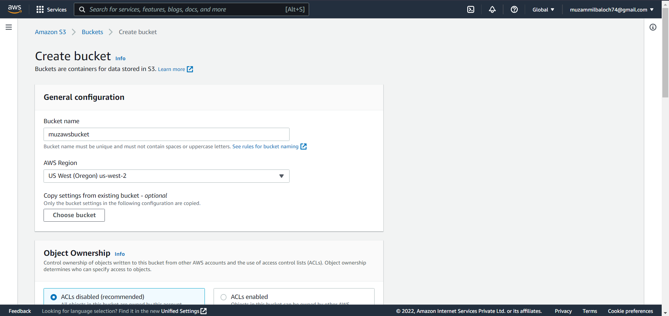

Step 5: Review the settings and create the bucket.

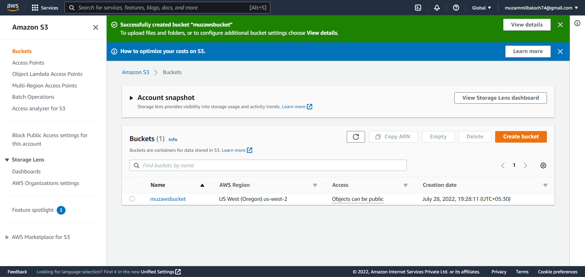

Step 6: Search for Lambda in AWS services.

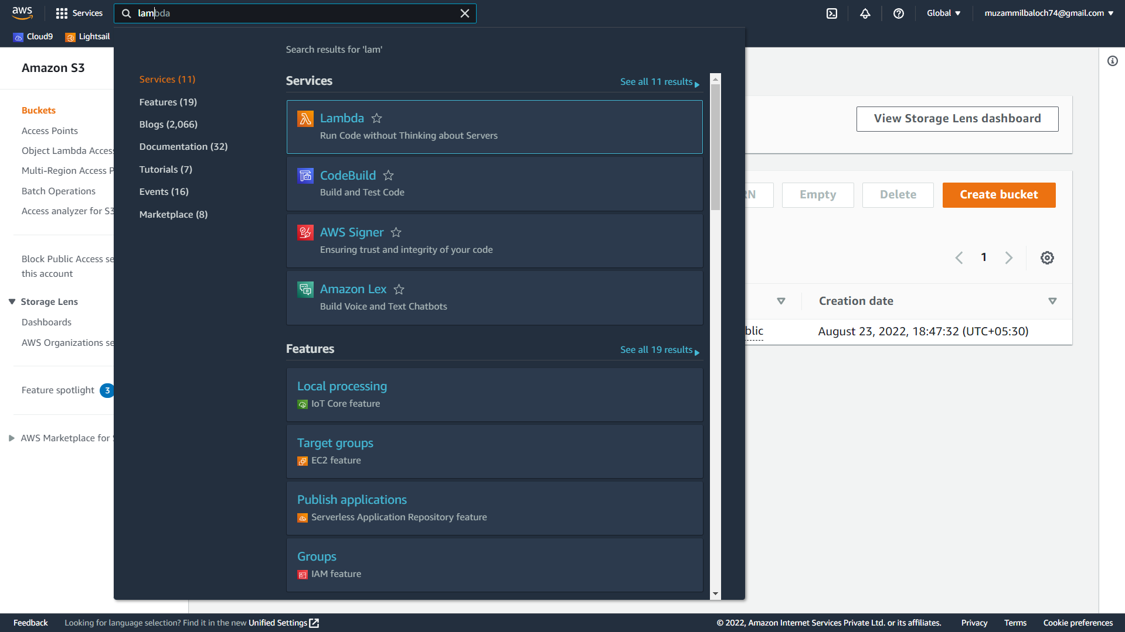

Step 7: Create a function.

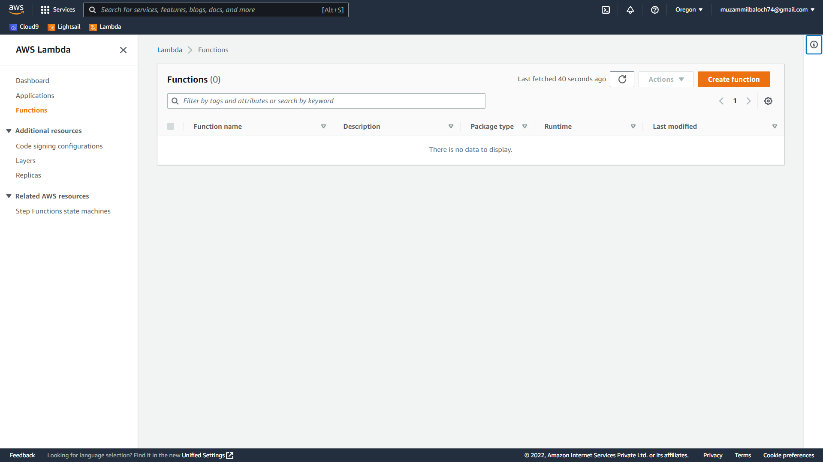

Step 8: Select s3-get-object-python blueprint.

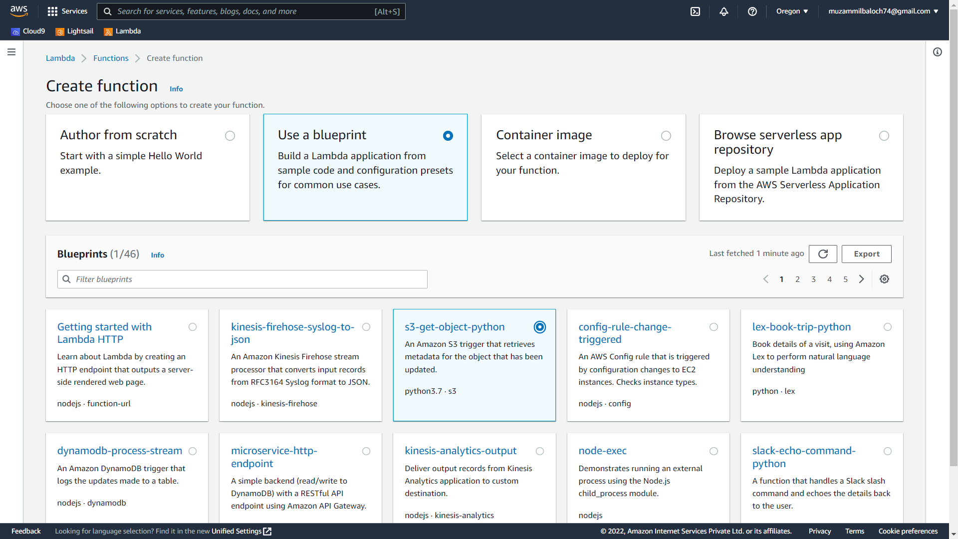

Step 9: Name the function and role.

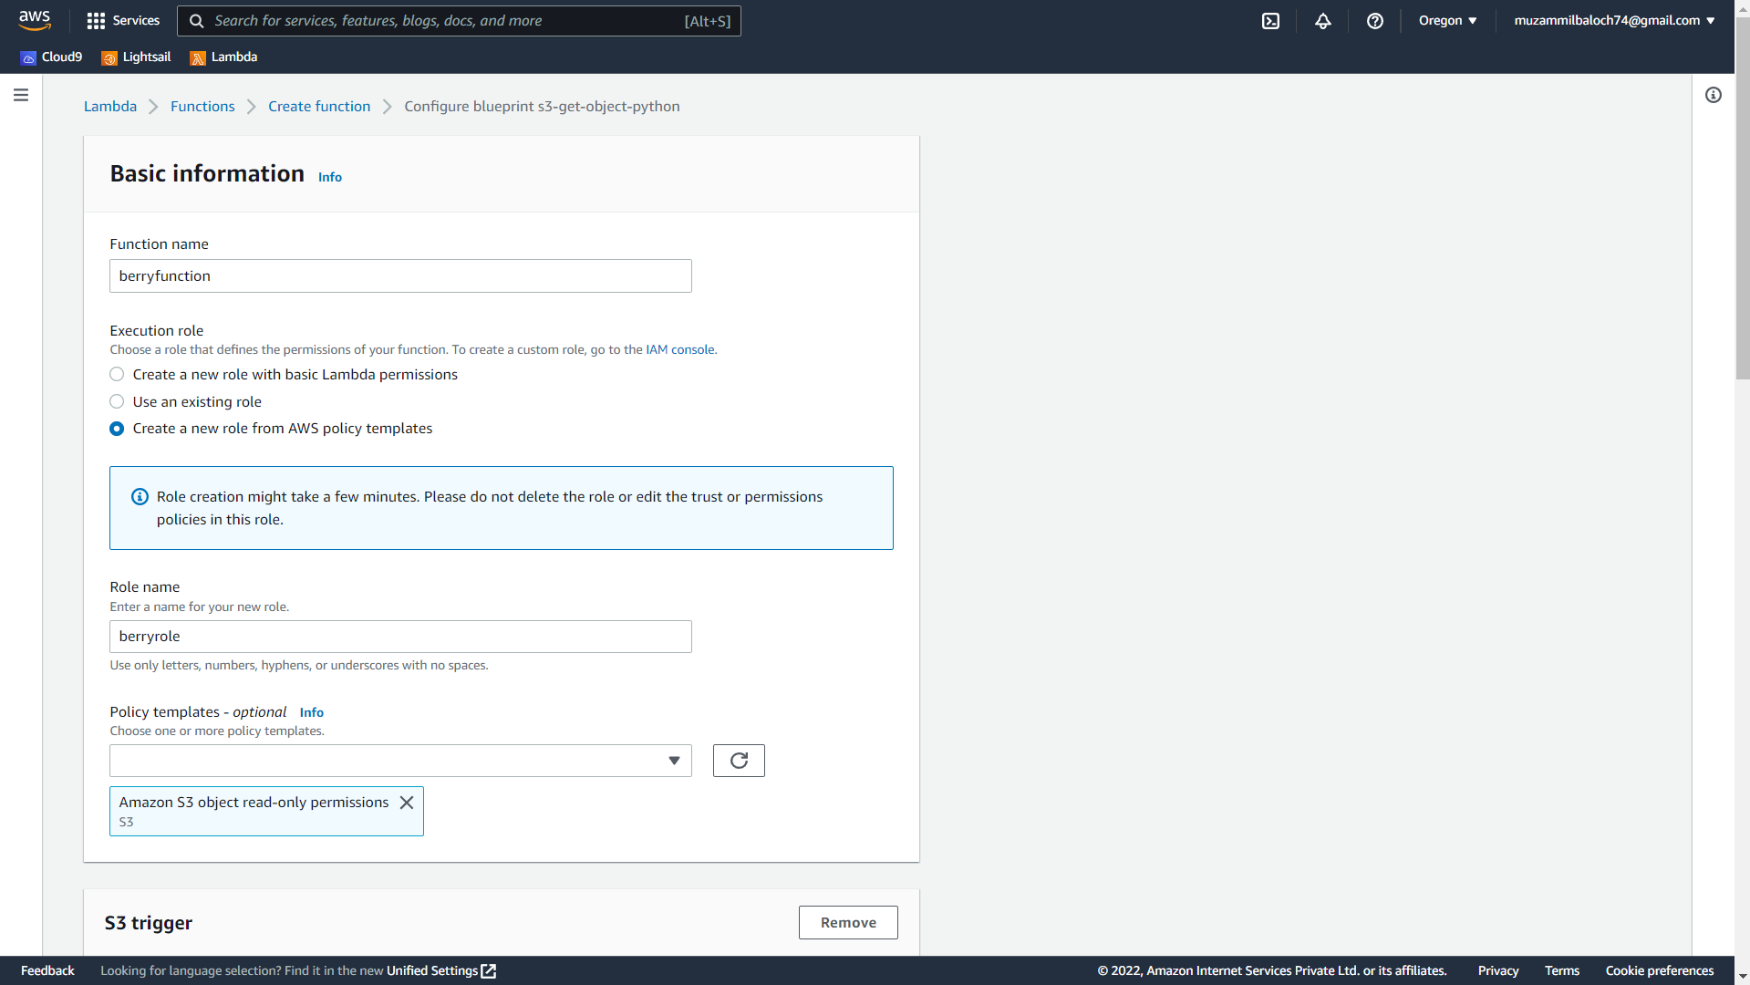

Step 10: Set S3 bucket as a trigger.

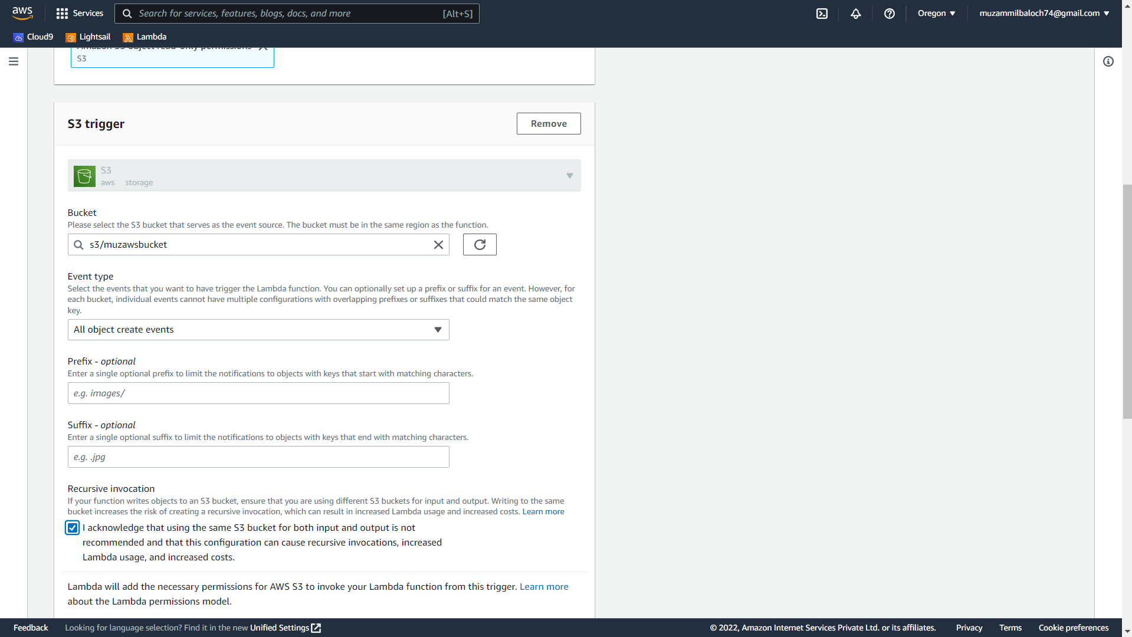

Step 11: Review the setting and create the function.

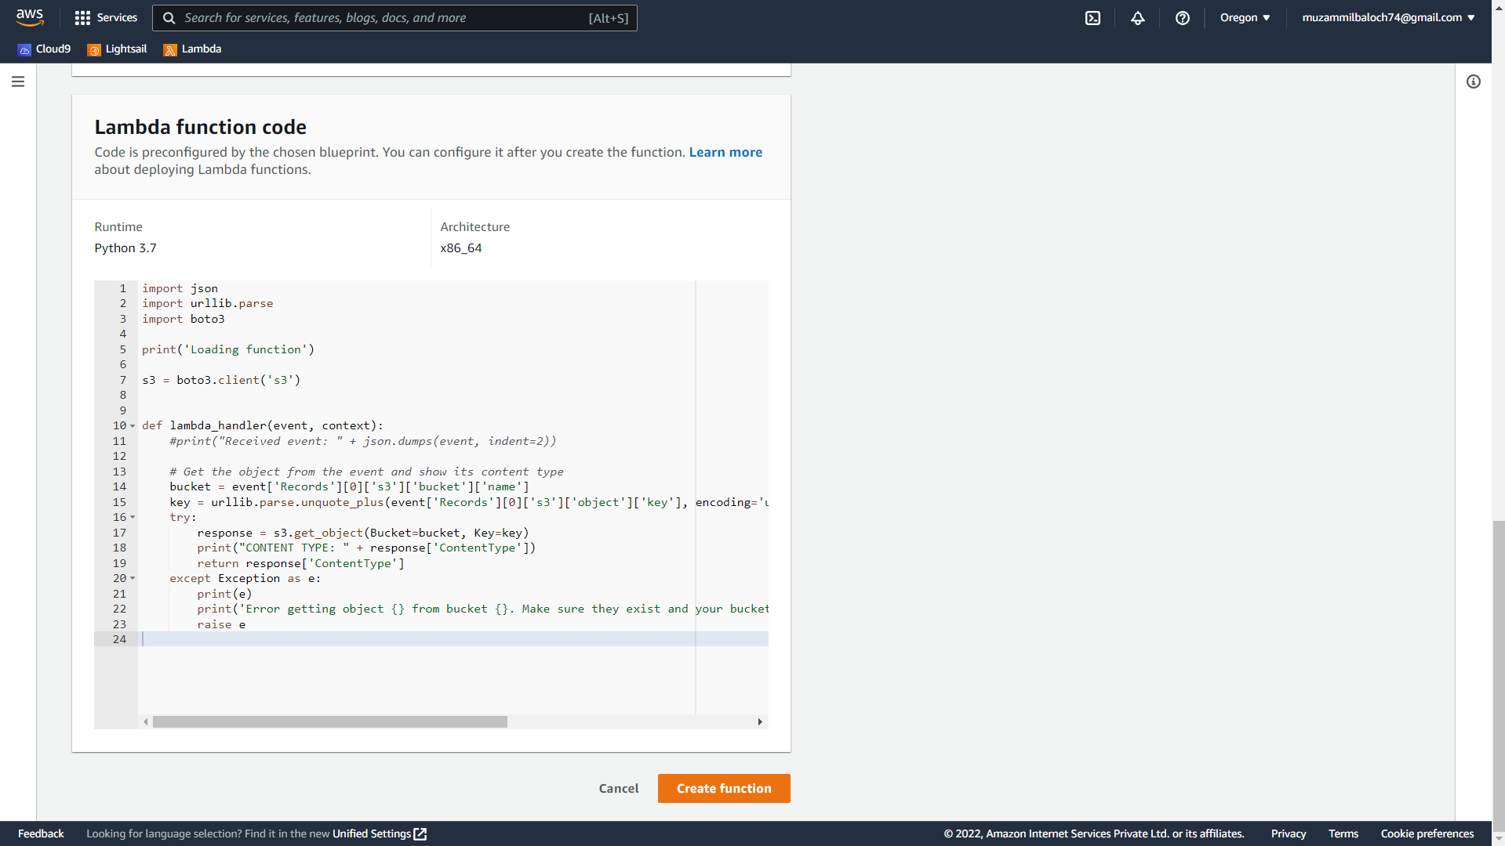

Step 12: Edit the code and deploy it.

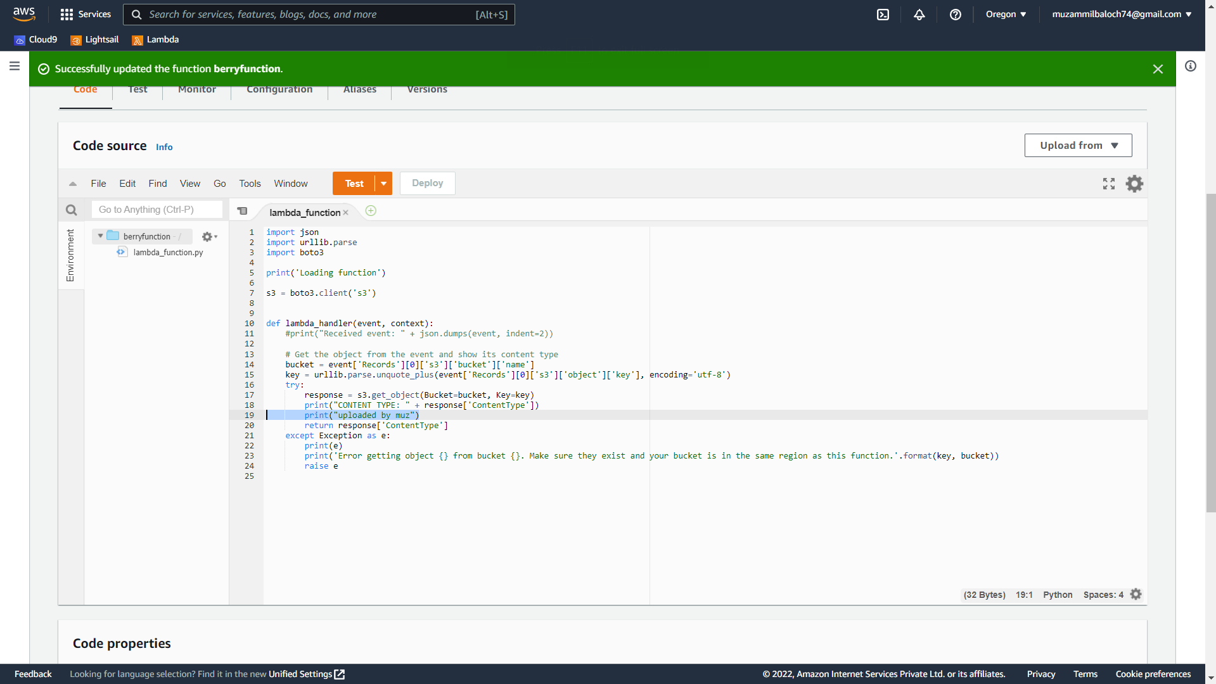

Step 13: Upload an object in S3.

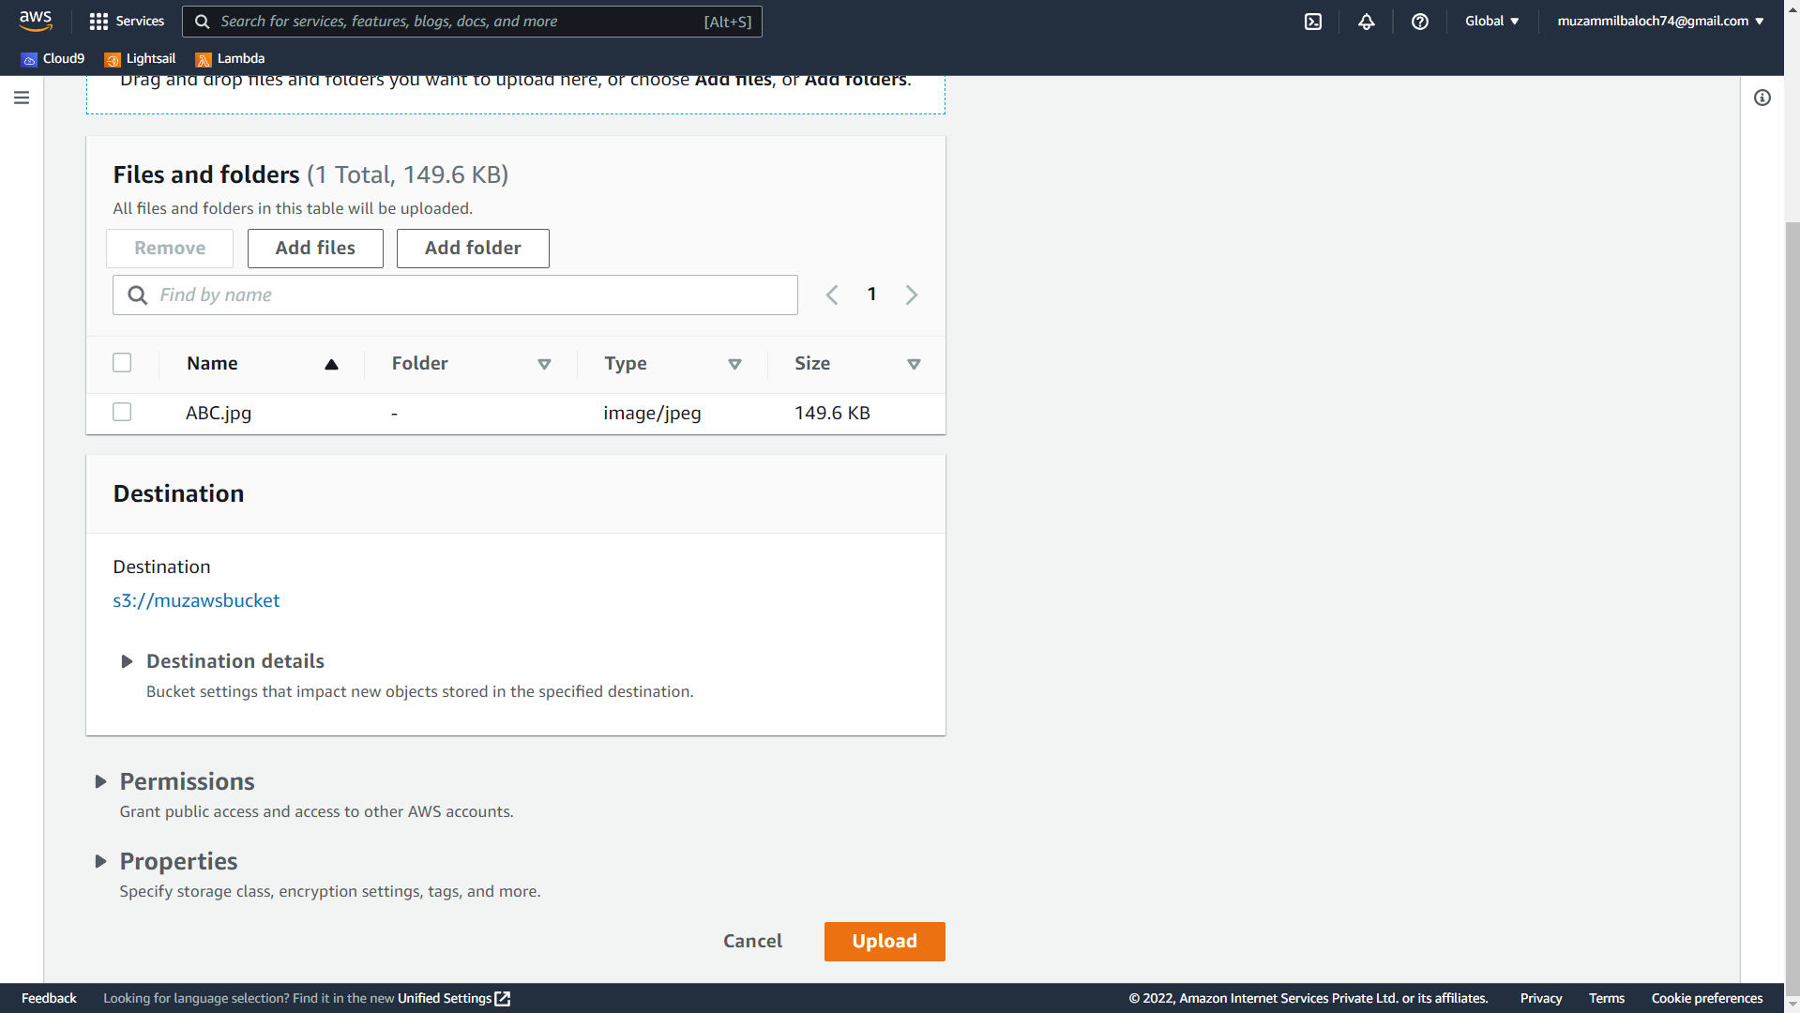

Step 14: In Lambda navigate to the monitor and select view logs in CloudWatch.

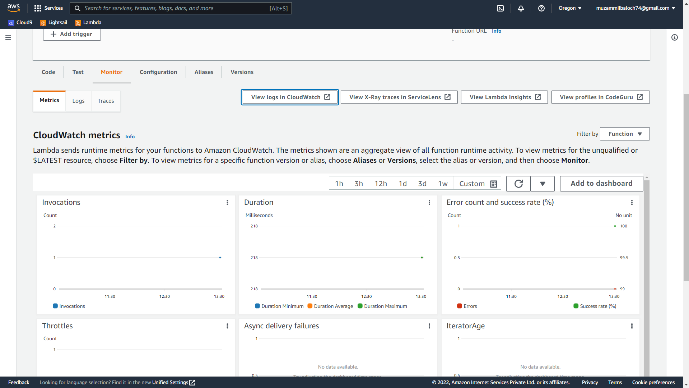

Step 15: You can view the log from this page.

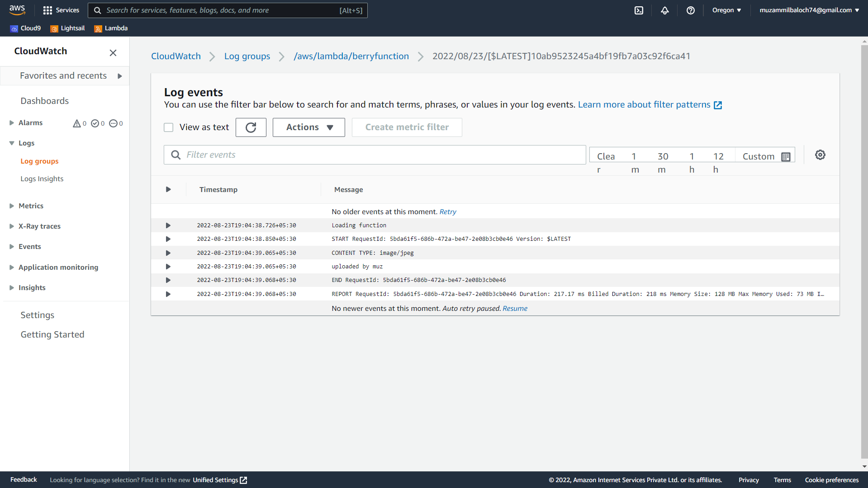

Step 16: Delete the function.

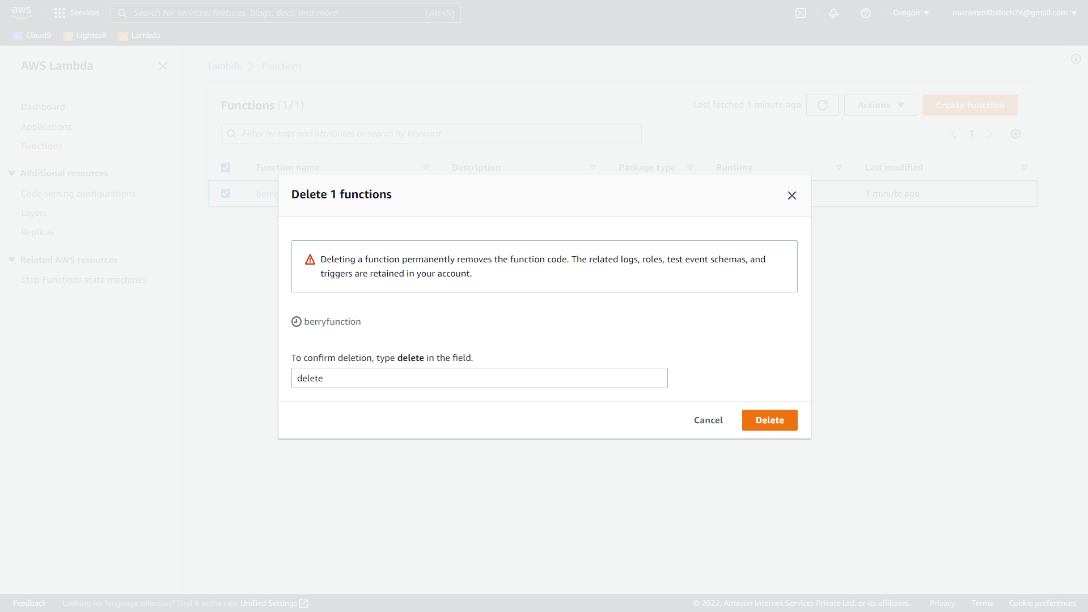

Step 17: Delete the bucket.

